* SAAS

**Software as a service** (or **SaaS**) is a way of delivering applications over the Internet—as a service. Instead of installing and maintaining software, you simply access it via the Internet, freeing yourself from complex software and hardware management.

**THE CLOUD… what is the could?**

<https://www.youtube.com/watch?v=gu4FYSFeWqg>

The ‘Meta’ or software living separately from the ‘data’ or software.

SaaS is a software delivery method that provides access to software and its functions remotely as a Web-based service.

Google, Twitter, Facebook and Flickr are all examples of SaaS, with users able to access the services via any internet enabled device. Enterprise users are able to use applications for a range of needs, including accounting and invoicing, tracking sales, planning, performance monitoring and communications (including webmail and instant messaging).

* **There are a number of reasons why SaaS is beneficial to organizations and personal users alike:**
* No additional hardware costs; the processing power required to run the applications is supplied by the cloud provider.
* No initial setup costs; applications are ready to use once the user subscribes.
* Pay for what you use; if a piece of software is only needed for a limited period then it is only paid for over that period and subscriptions can usually be halted at any time.
* Usage is scalable; if a user decides they need more storage or additional services, for example, then they can access these on demand without needing to install new software or hardware.
* Updates are automated; whenever there is an update it is available online to existing customers, often free of charge. No new software will be required as it often is with other types of applications and the updates will usually be deployed automatically by the cloud provider.
* Cross device compatibility; SaaS applications can be accessed via any internet enabled device, which makes it ideal for those who use a number of different devices, such as internet enabled phones and tablets, and those who don’t always use the same computer.
* Accessible from any location; rather than being restricted to installations on individual computers, an application can be accessed from anywhere with an internet enabled device.
* Applications can be customised and white labelled; with some software, customisation is available meaning it can be altered to suit the needs and branding of a particular customer.
* Office software is the best example of businesses utilising SaaS. Tasks related to accounting, invoicing, sales and planning can all be performed through Software as a Service. Businesses may wish to use one piece of software that performs all of these tasks or several that each perform different tasks. The required software can be subscribed to via the internet and then accessed online via any computer in the office using a username and password. If needs change they can easily switch to software that better meets their requirements. Everyone who needs access to a particular piece of software can be set up as a user, whether it is one or two people or every employee in a corporation that employs hundreds.
* **Summary**
* - There are no setup costs with SaaS, as there often are with other applications
* - SaaS is scalable with upgrades available on demand
* - Access to Software as a Service is compatible across all internet enabled devices
* - As long as there is an internet connection, applications are accessible from any location.
* **What I noticed:**
* **Freckle:**
* - SAAS offers business solutions first and formost
* -Provides the questions you want the answers to without having you ask them
* -Sympathetic to our business needs – understanding undertone.
* - Provides user testimonials that are hot topic
* -Show’s you the benefit
* - “Start your FREE 30 Day Trail. Now!”
* - provides pricing straight up – seems to have no hidden fees associated with package
* - Different needs associated with different package offerings
* - More testimonials / rave reviews from credible sources, Forbes.
* **Hoot Suite:**
* - Offers point blank offereing.
* -Free 30-day trial offered – Start now option even before scrolling further down the browser
* - Provides a tally of current users – all Big Name Brands.
* Follow’s up with a START Now button.
* 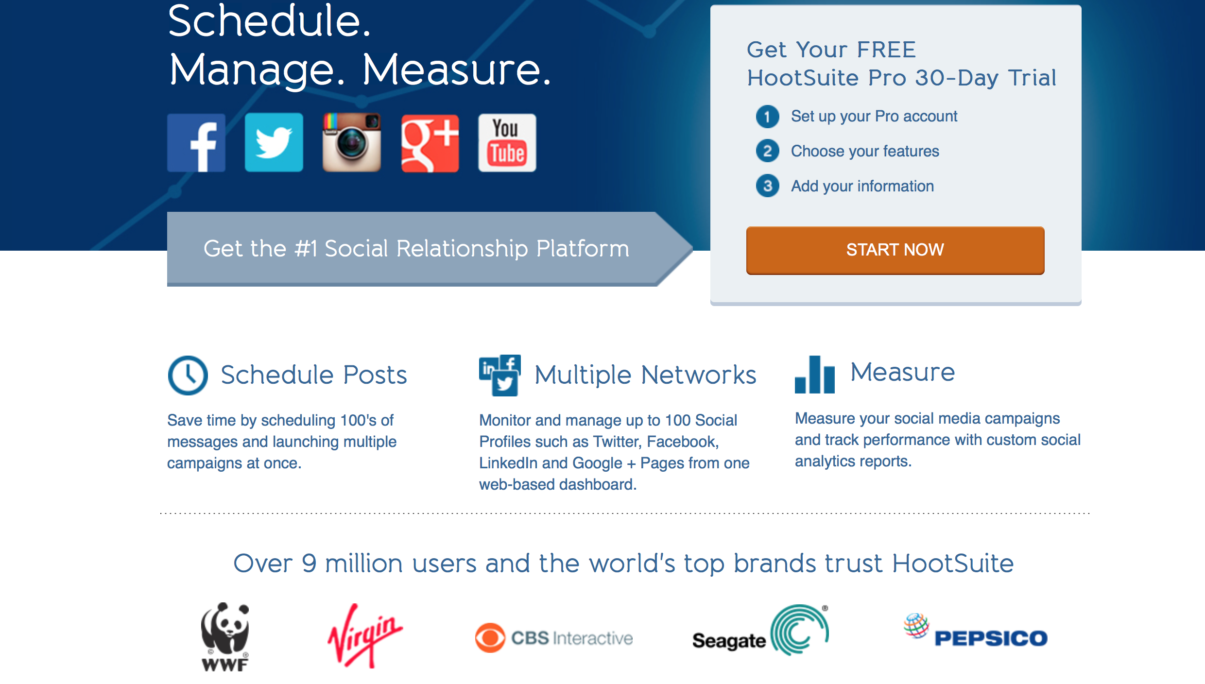
* **Digital Ocean:**
* - Sign up, Sign in, Log out, Learn More
* - INFOGRAPHIC’s galore.
* - Boasts user interaction and benefit, easy interface, simplicity. – WHY wouldn’t you try it?
* - Offer’s tours/ demos
* - Pricing plans
* - More user testimonials and criticality acclaimed standings in the B2B world.
* **Freshbooks:**
* - FREE, FREE, free, TRY FREE, Sign Up FREE!
* - User log in first thing you see
* - Makes a hard daunting task look fun and easy. Accounting ew.
* - Provides a solution for the individual who would alternatively have to hire someone else and pay someone else to do.
* - Let’s you hold the success and control of your company without third party.
* - This makes me want to do my taxes. HOOK. LINE and sinker.
* **Atipso:**
* - Descriptive and bold header.
* - A free trial offering
* 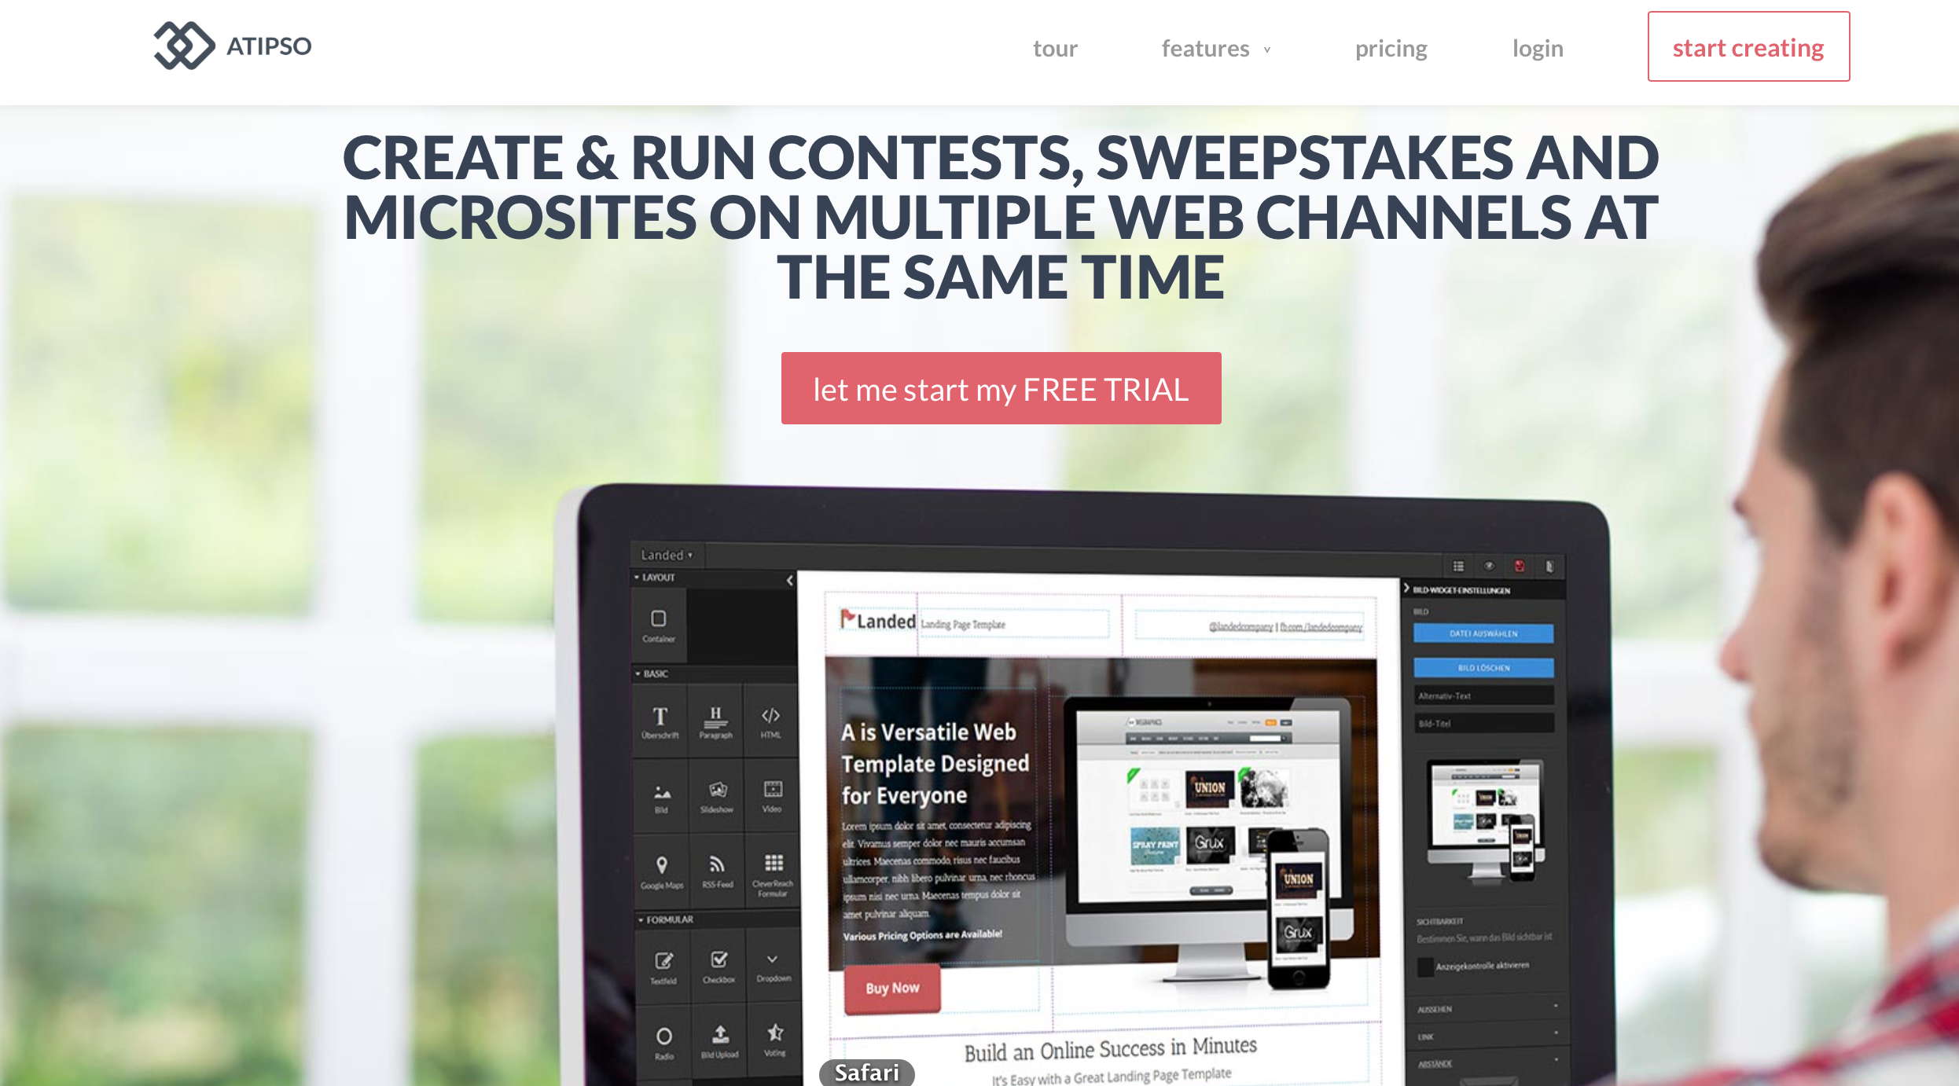
* - Visual of the working app
* - Easily understandable info graphics that show product offering without having to read too deeply into the software
* 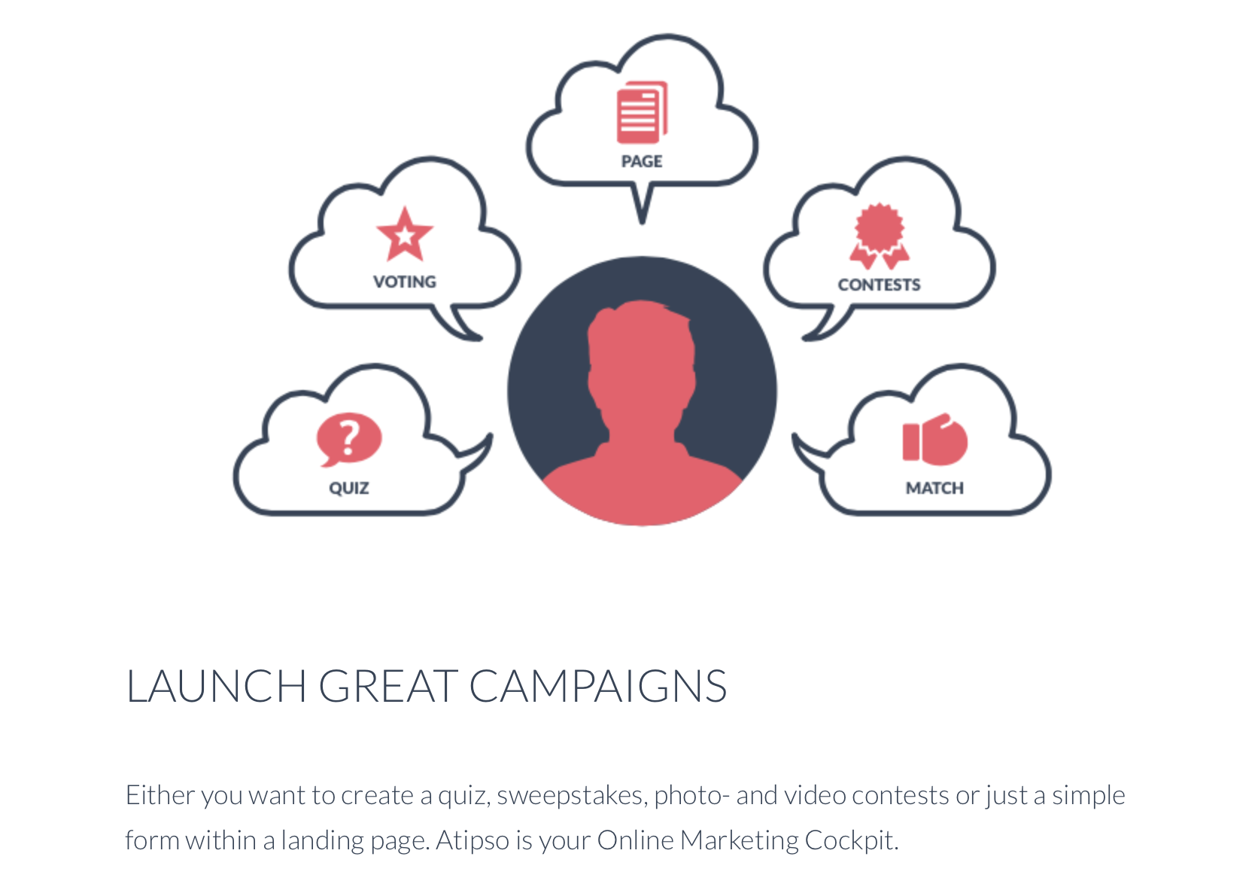
* **MailChimp:**
* -Right off the bat – in the header they are telling me what they can do for me.
* - How this SAAS can improve my life
* - Bold statement : More than 7 million people use MailChimp to design and send email marketing campaigns. Join them today.
* - Followed by the Sign up
* - Offer the three part package. S, M, L

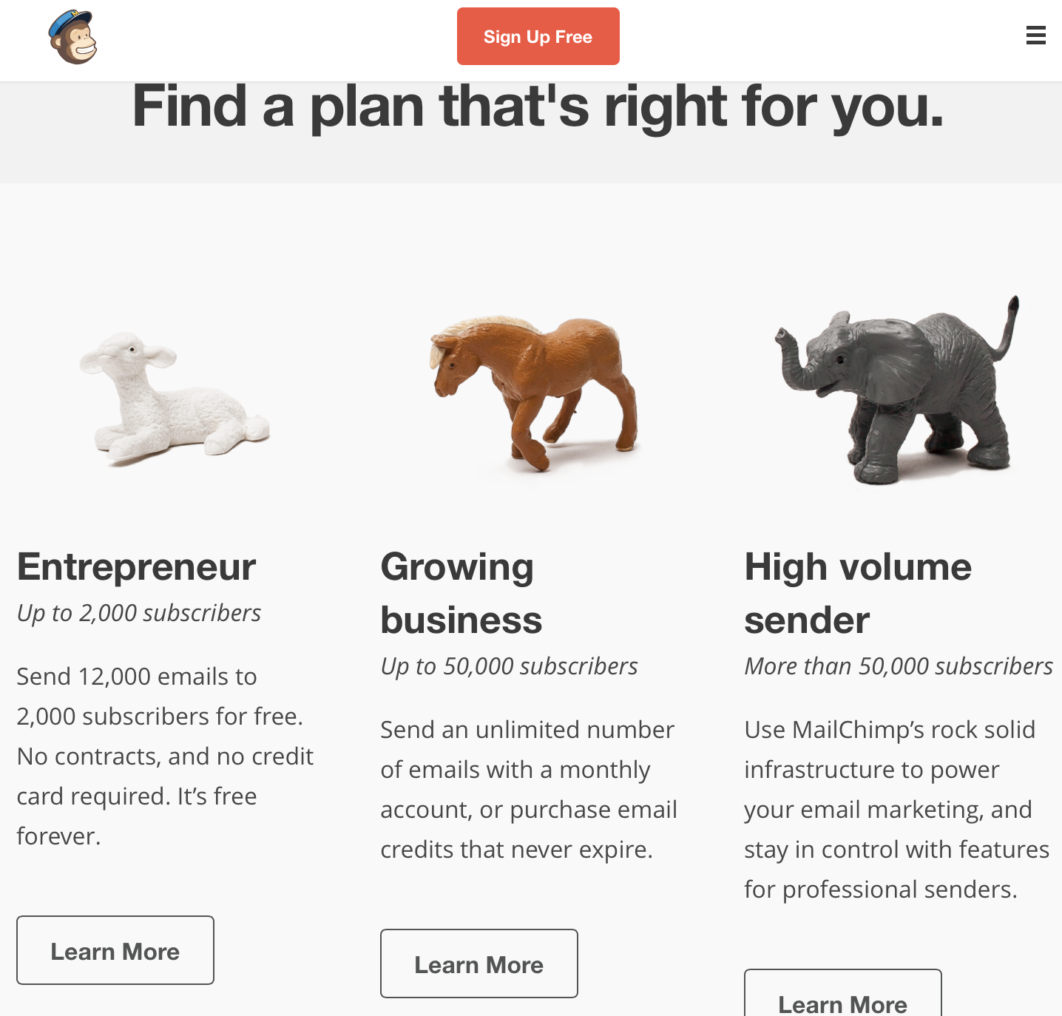

-D’aww – this is kind of a self actualization scheme if you think of it. Humans become incredibly attached to their children…. I mean businesses. Are you a small competitor who only deals with one on one interactions with clients or are you a competitor to be reckoned with. I’d pay for more assuming we could eventually get there.

- More expensive must be better right, not actually.

“Use MailChimp’s rock solid infrastructure to power your email marketing” what happened to free emails and subscribers on the entrepreneurial plan.

**Invision:**

* Direct offering within seconds of scanning the site.
* Do you need help improving one of the following… ?

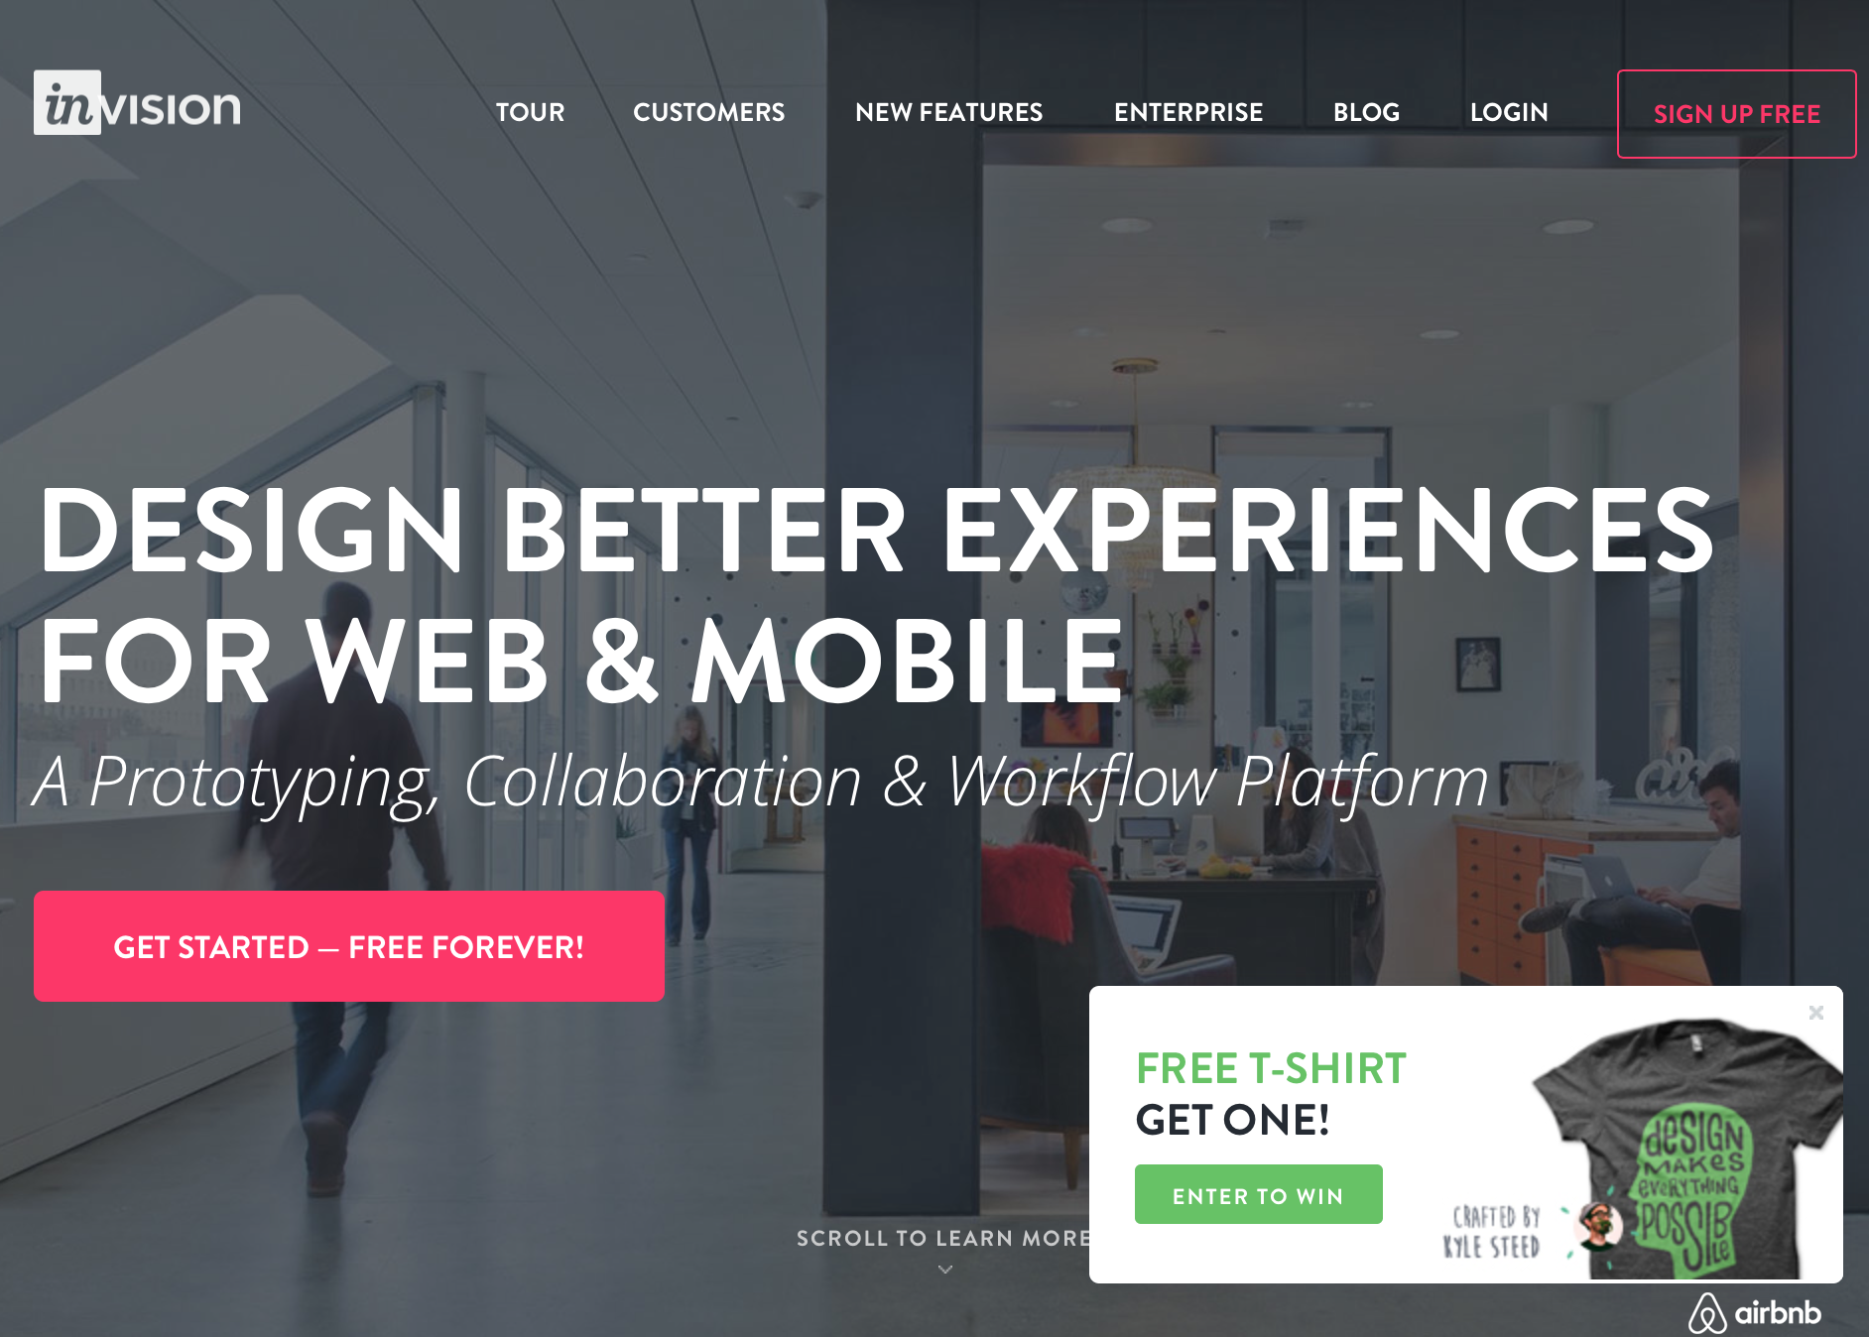

-Well you can Get Started for Free and Forever and you get a FREE T.

- Captures the **why not** try it, what do you and your up and coming business have to lose.

* Show’s customers what they can do and who they do it for. Taking testimonials to a new level.

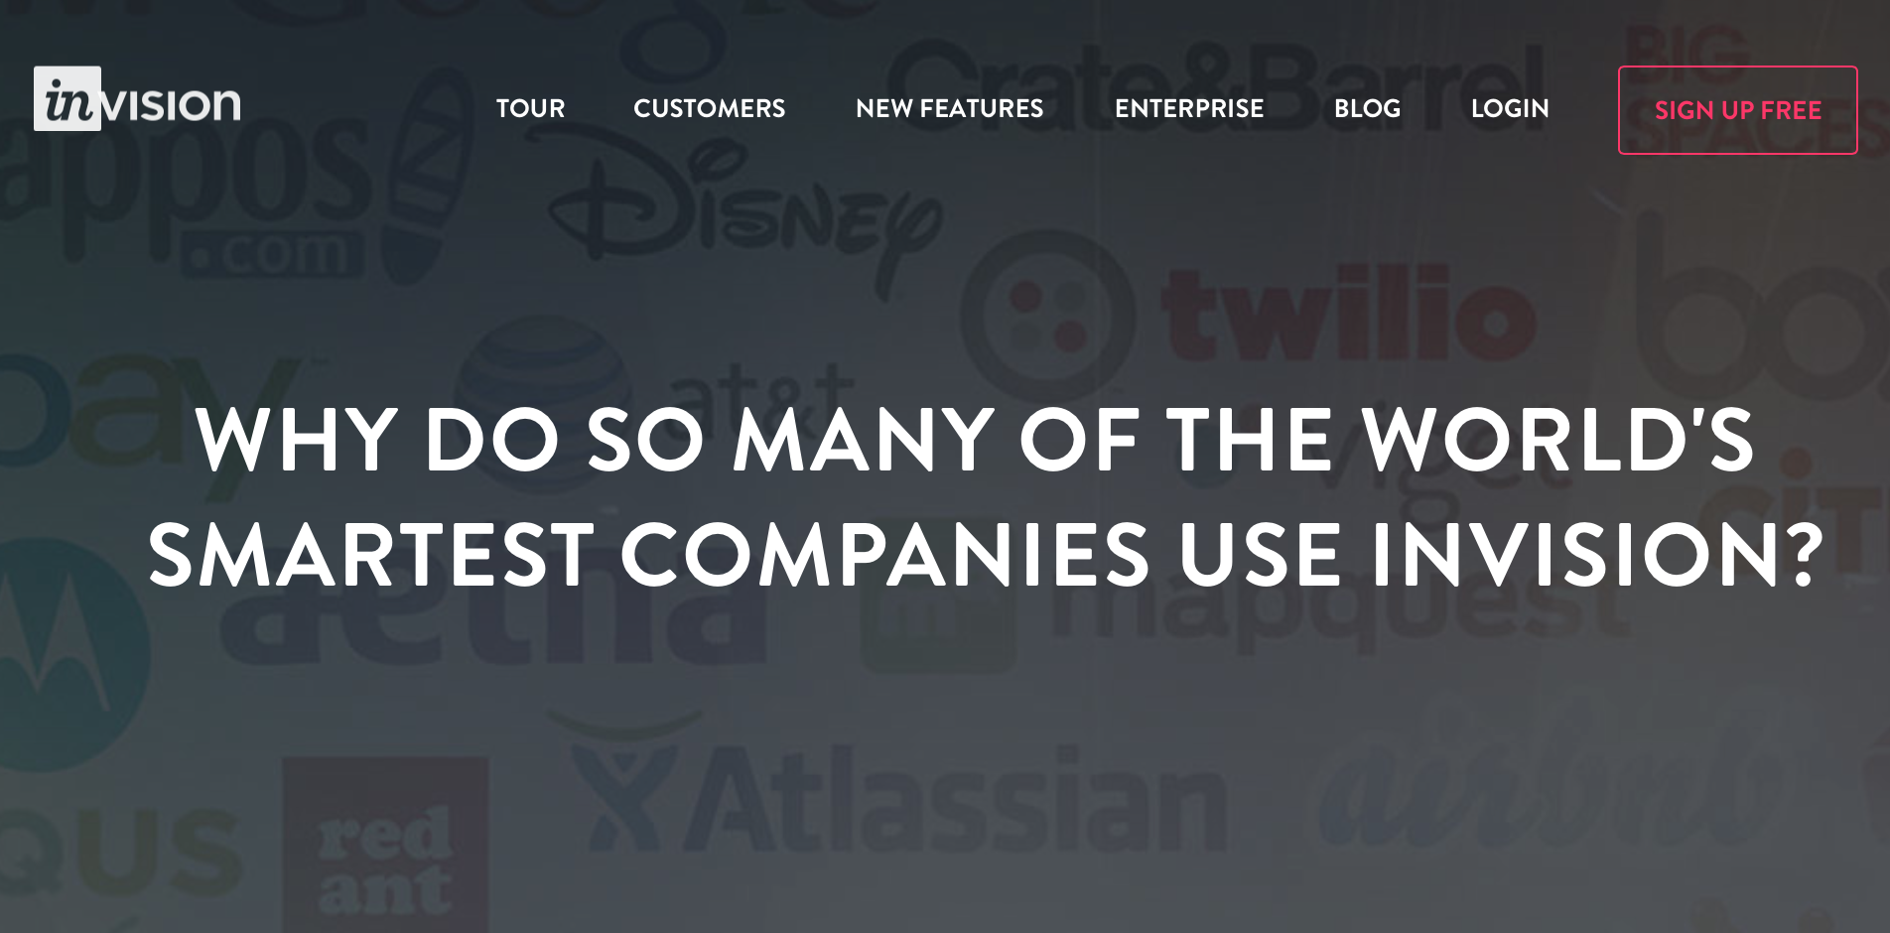

ADOBE, ESPN, BOOM, PRESI, EVERNOTE, DISNEY, Shopify, Basecamp… the list goes on.

* shows how they each use it and why it helps them.

**SAAS FACT : Providing individual solutions to individual needs.**

Basecamp:

* Show’s product offering through imagery

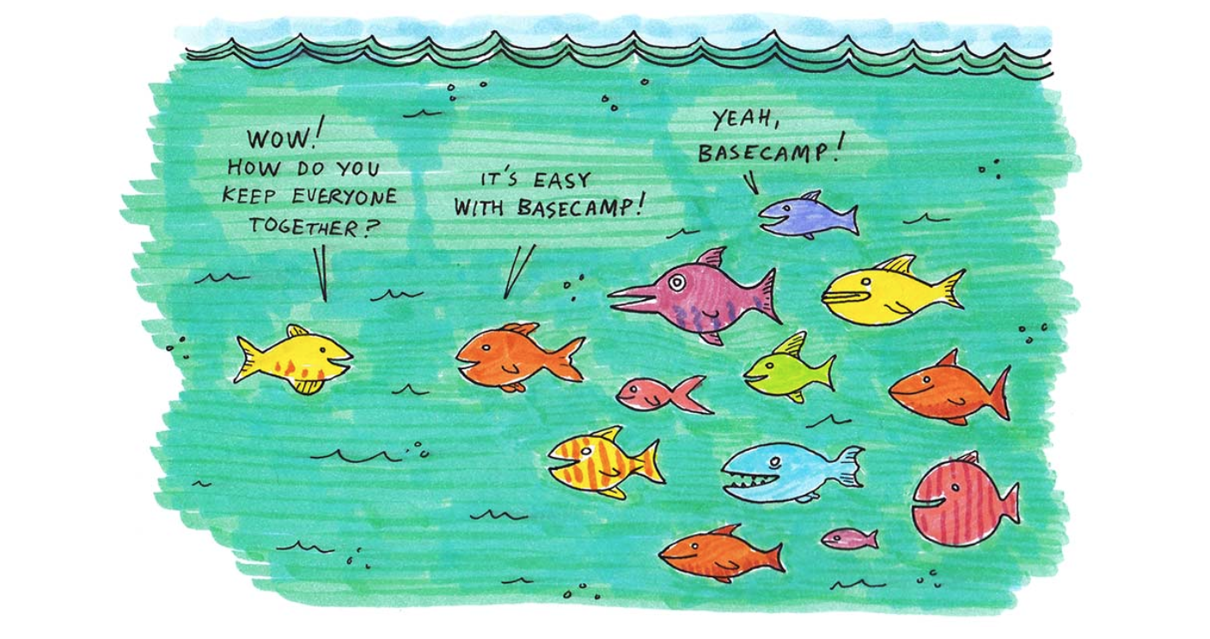

* Without reading I know Basecamp connects and unifies users.
* Point blank offering listed
* Countless options to sign up free at any point along the way.

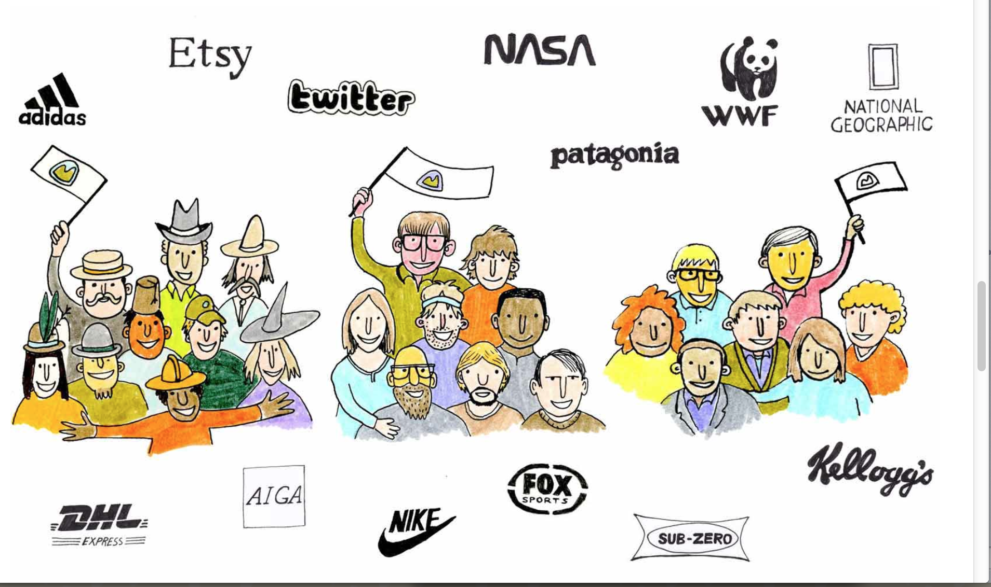

**SASSFACT: CREDIBILITY THROUGH ASSOCIATION**

* I have decided to create an account with **Evernote**. It’s one of those things you claim to know about cause you’ve heard of it countless times but when it comes down to it you have no idea what it is. I hear its beneficial, I see it on the App store, I know it’s used by small…business….people to org…anisee…remember. I don’t know what it does so now is the opportunity to divulge in all things Evernote.
* STEP ONE: Find the Sign Up here button. Hmmm… OH there it is, lost it for a second in the green grass. Here I go.
* 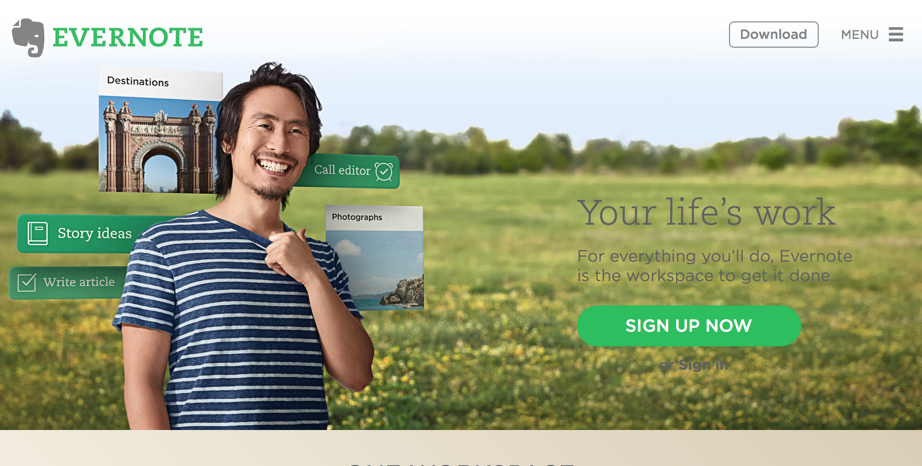
* STEP TWO: Just an email and a password and I’m in. Easy, fast and user friendly
* 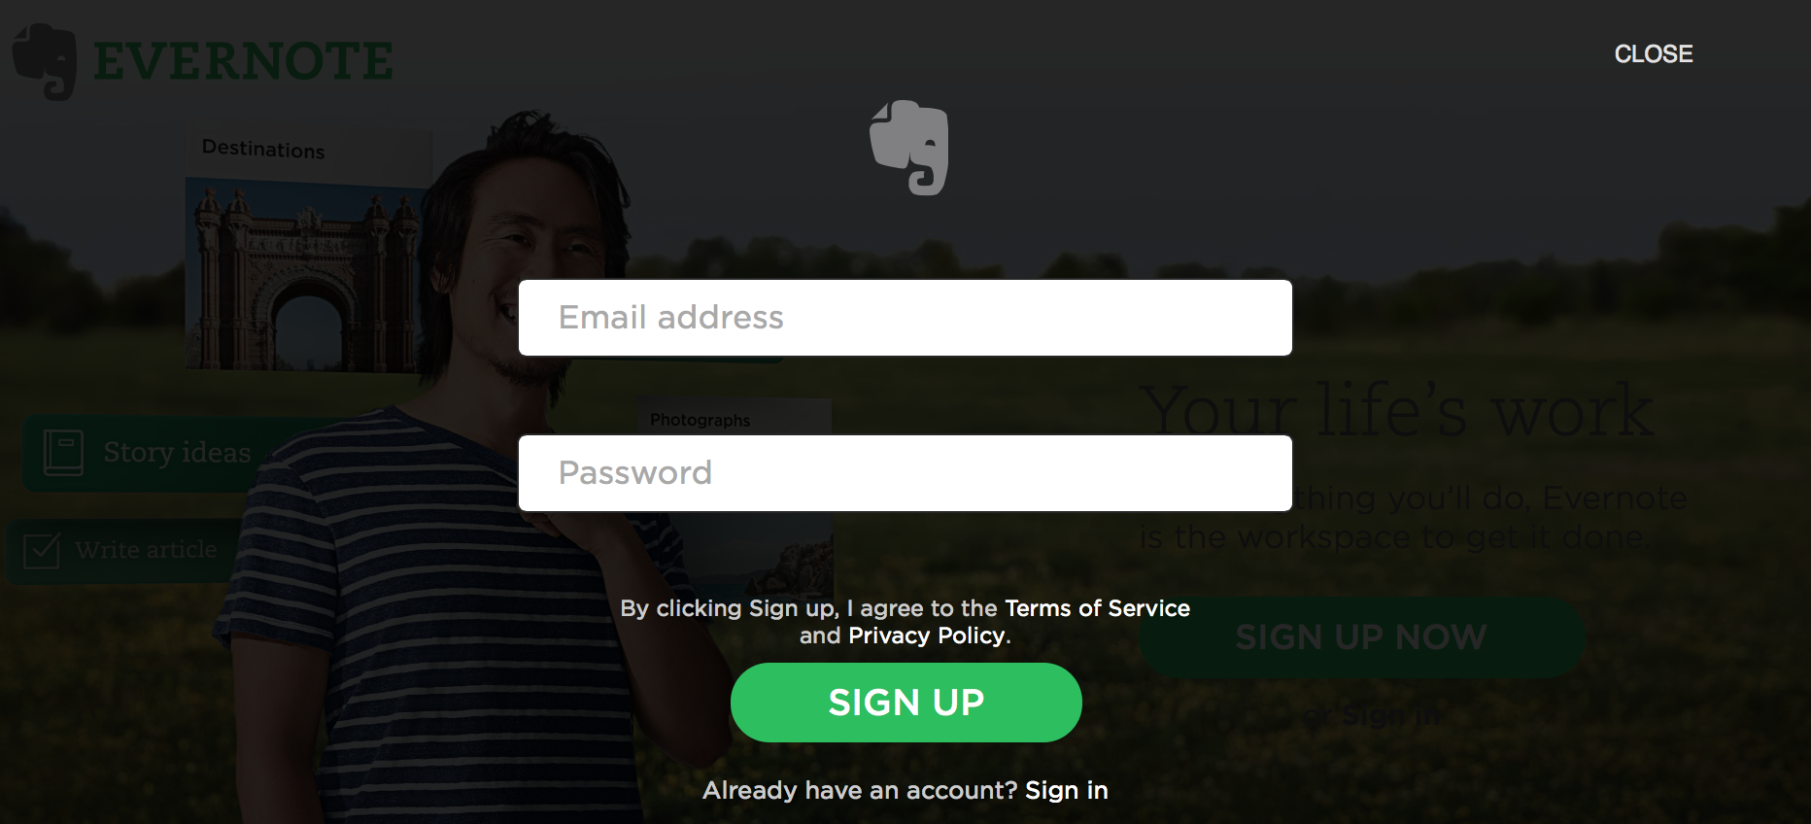
* STEP THREE: Before I even get to know the site/ tool they offer me the choice to upgrade to the premium package or if I am a business an option to align my Evernote account with that.
* 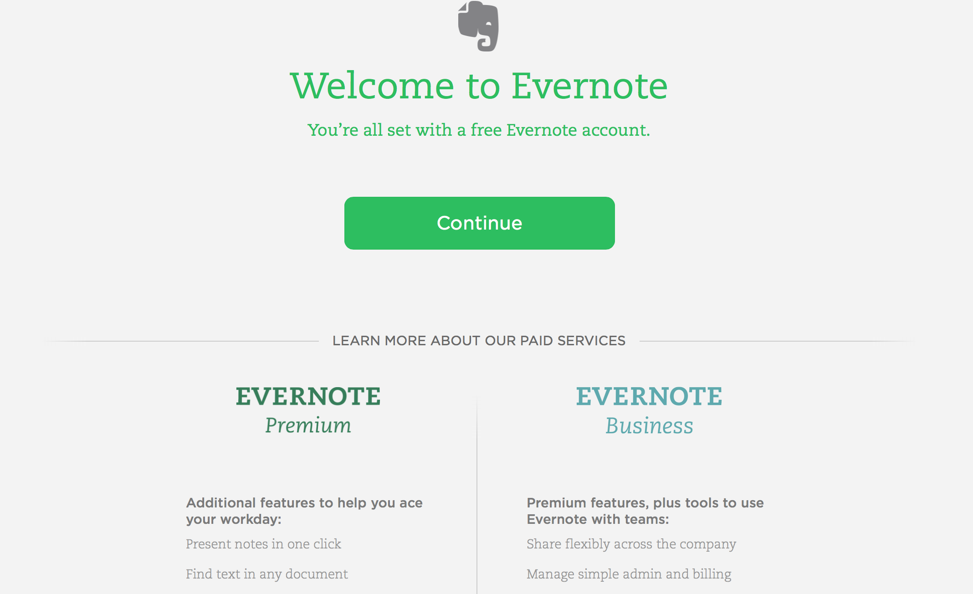
* I continue. Was asked to verify my confirmation email.
* 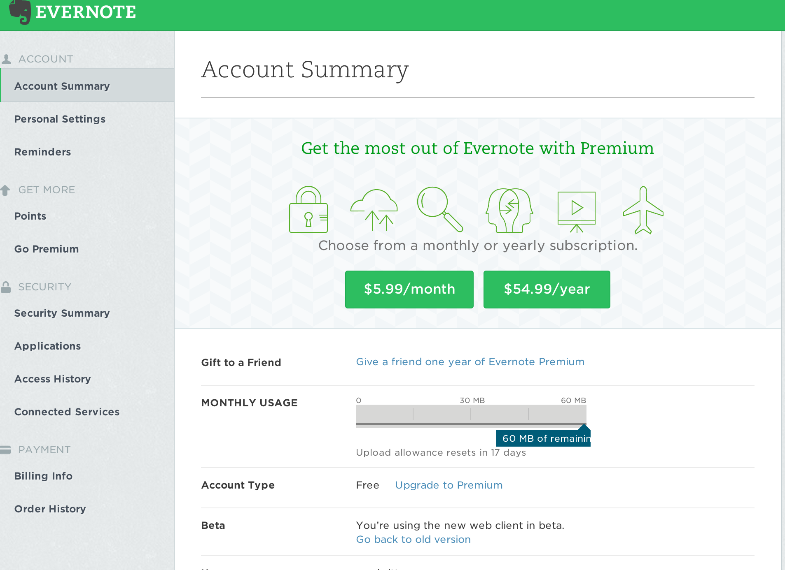
* Before knowing anything – I am asked again if I would benefit from going premium. I decline.
* 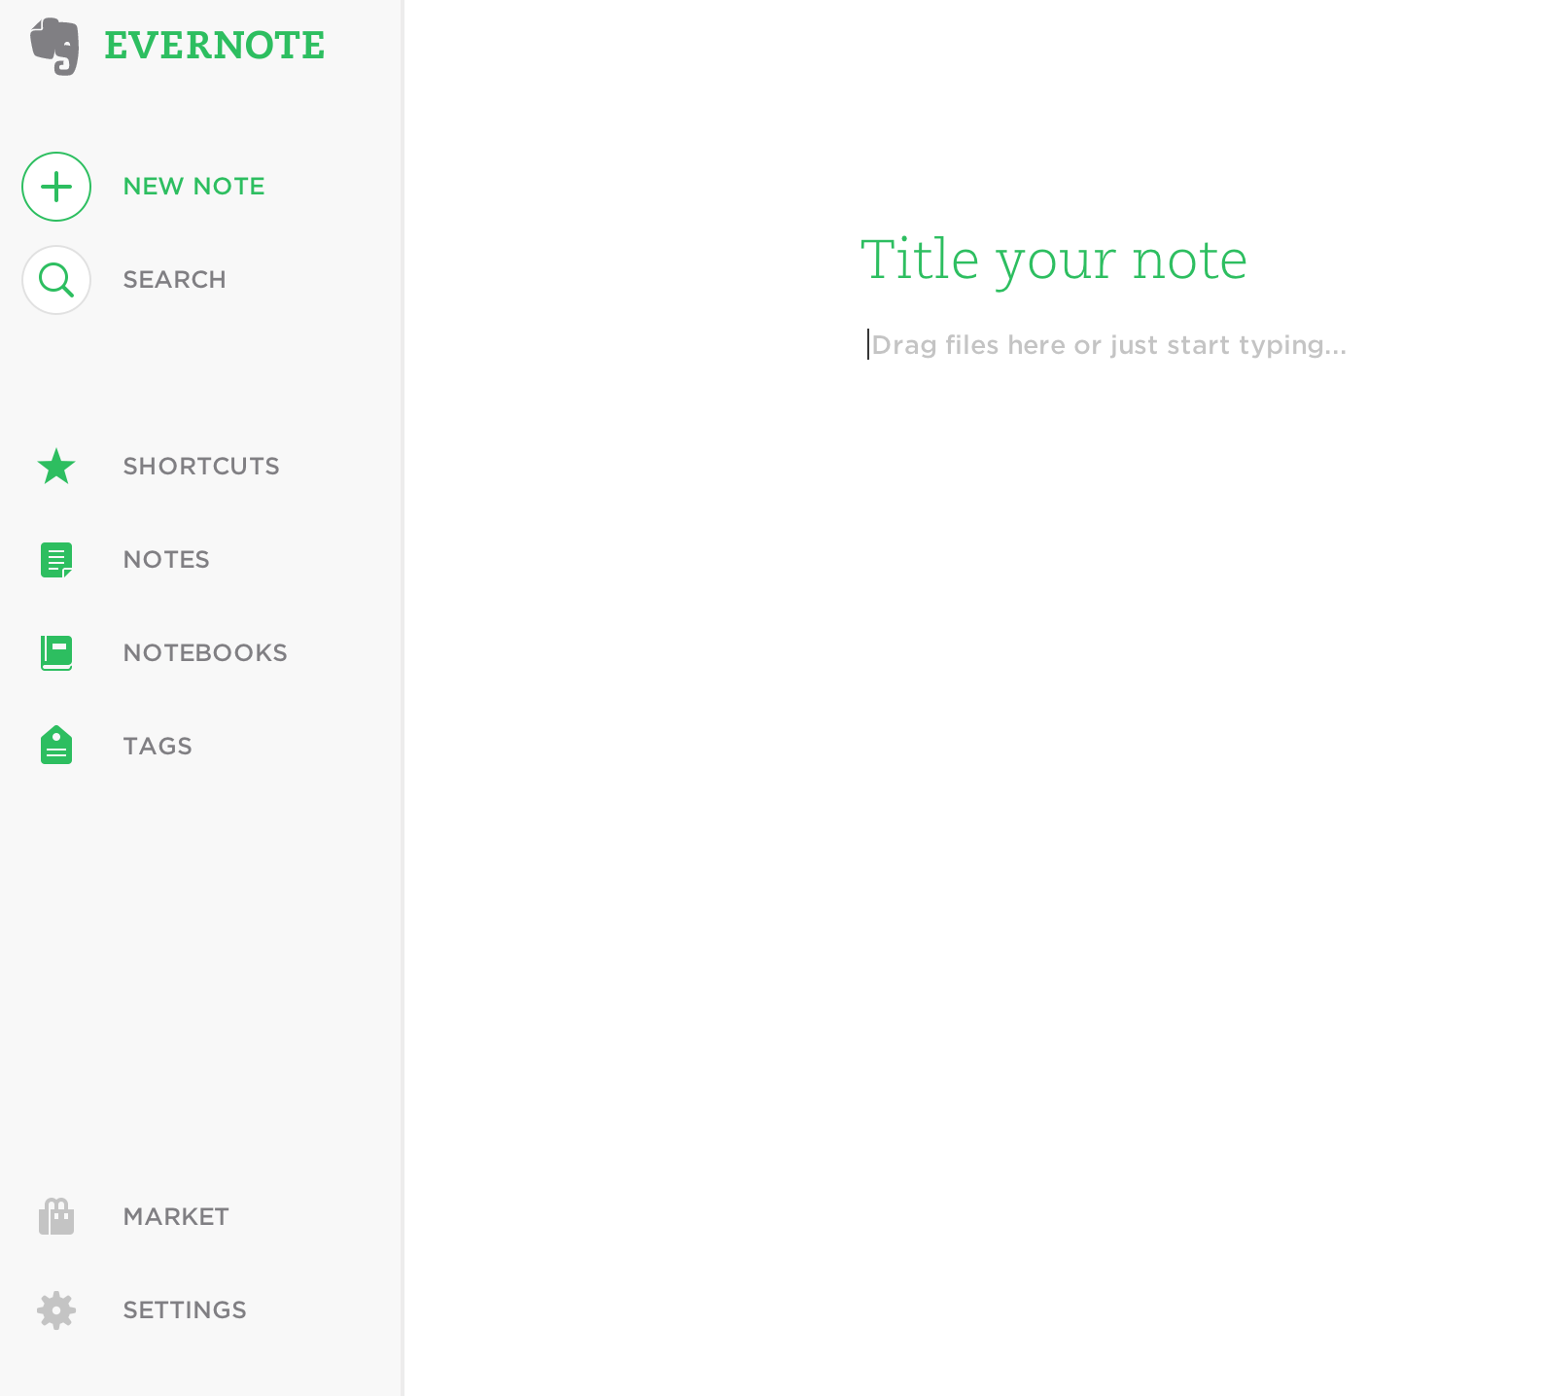
* I am then brought to this crisp and clean writing tool? Where I have a navigation of choice to choose from. I write a TO DO list and a ilst of things I need to pack for my next business trip. But is this the extent of Evernote?
* I decide to seek help with learning and click on Help & Learning.
* 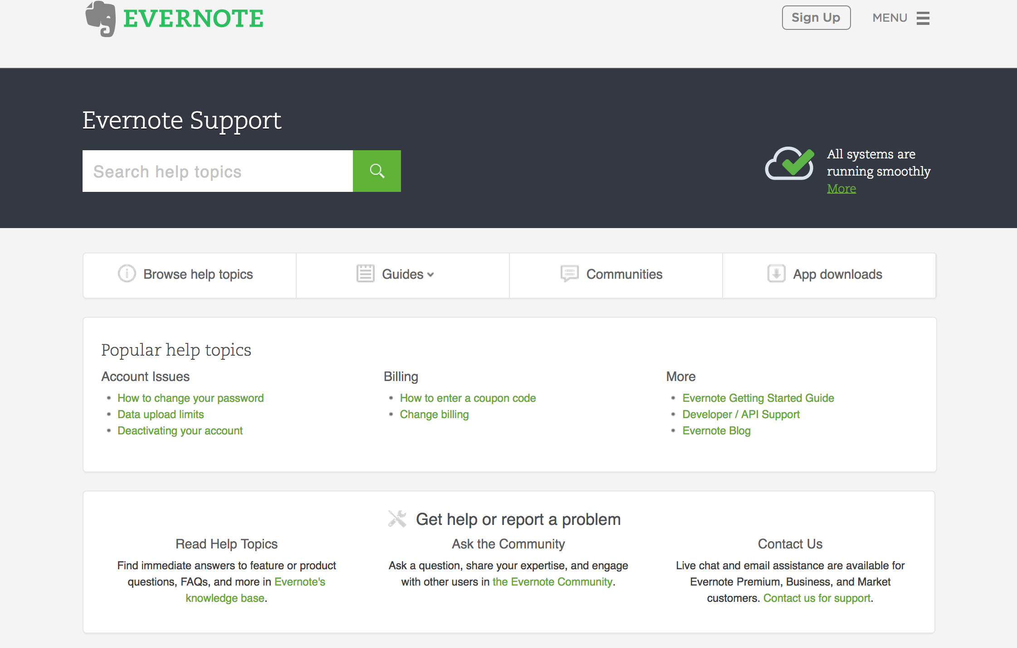
* And it begins – There are a number of interactive video’s to show me how to get the most our of using Evernote.
* 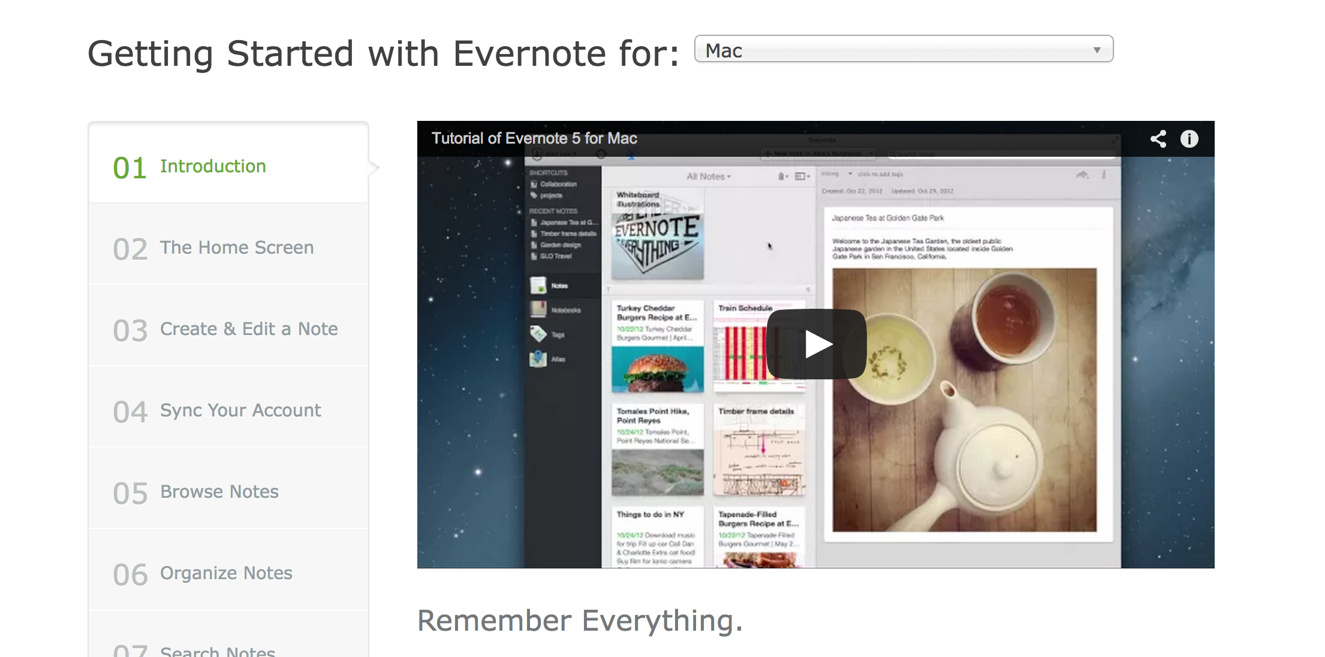

Identify the UI and content patterns specific to SAAS product storefronts.

* **User Interface Patterns**
* A detailed description of the top 5 UI patterns revealed common to the SAAS industry
  + **Logo in left hand corner**
* Most SAAS B2B websites had their logo at the top left hand corner of the webpage. This area of the webpage is where the viewer’s eye goes first so it’s a fitting place for the logo.The look and feel of the logo also introduces you to the style of app, some were playful and creative other serious and professional.
* 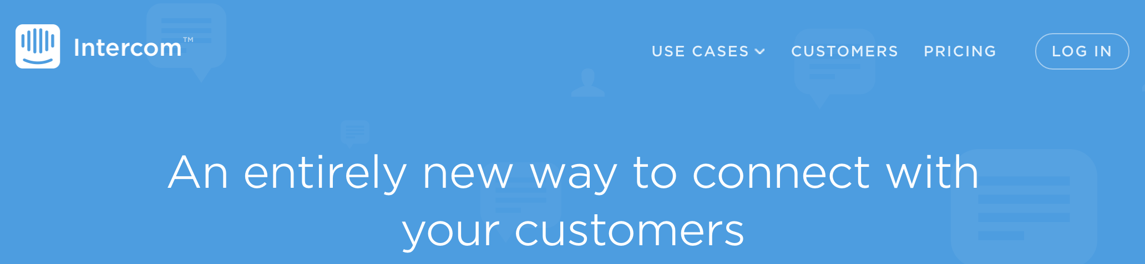
* 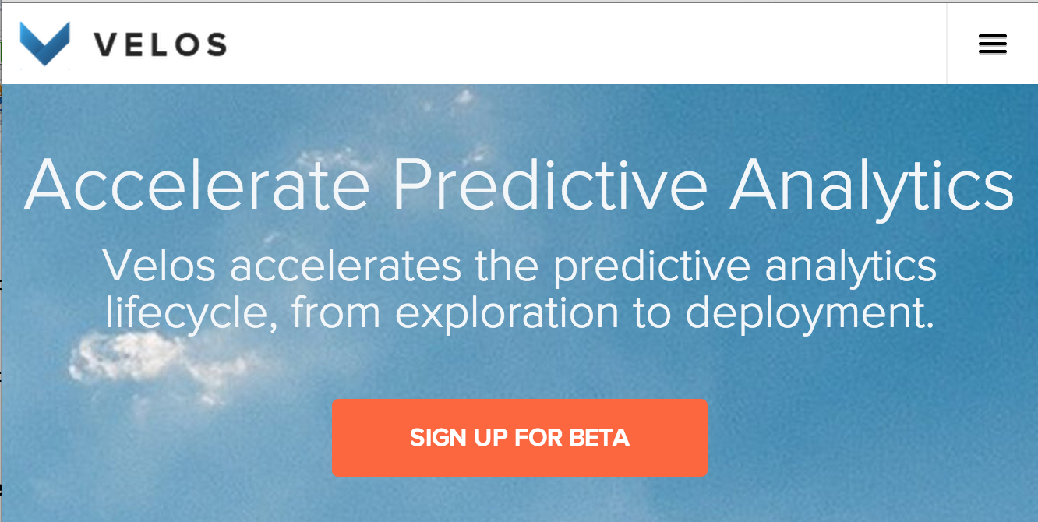
  + **Navigation bar that spans the top of the page**
* The navigation bar for most of the websites I visited fell at the top of the page. The navigation bar contains the fundamental information the viewer is looking for when visiting a platform orientated website. Button’s like the about, contact, how to get started, sign up, pricing etc. The navigation bar is the foundation of any website and should be concise clear and one of the first things you see.
* 
  + **Point Blank Sign UP Buttons**
* If not on the very first page a bright ‘click me’ sign up button can be found multiple times throughout a SAAS website. Repetitive buttons reinforce a users decision to try a new product and the fact they reiterated the fact that the trial or basic package is free is just another reason to click and give it a try.
* 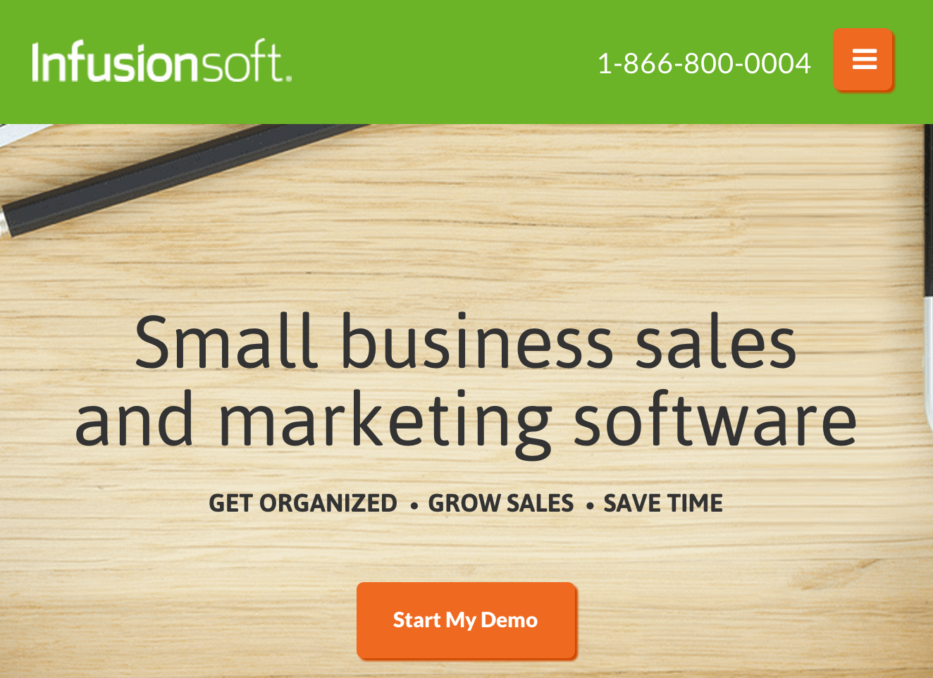****
  + **Pricing Pages**
* Every single SAAS website had a pricing page. SAAS platforms are products to therefore have an associated cost with amount of benefit received. Most website’s had a three tier pricing plan, a basic or free option, an upgrade from basic moderate price option and offering and a premium offering of exceptional services. What I liked about the marketing of the various tier’s from Website to Website was the subconscious message associated with the plan’s price.
* New businesses want what’s best for their baby, they want what they will benefit most from and will generate most success – I feel as though this page can really sway a future user to up their price when comparing their business to the product offering offered for example in the photo below: By asking are you? Basic, intermediate or premium customer they are essentially saying is your business a naïve lamb or do you have what it takes to be a colossal elephant, in a fun egotistic, round about way.
* 
  + **Inforgraphics**
* Most of the websites I visited had at least some sort of inforgraphic in one section of their website or another. Inforgraphics make taking in and registering information faster and easier. Instead of a future customer having to read through a bunch of content to decide whether the app is for them or not they can simply enquire (by scrolling) look – understand – and associate with the visual offering the site has provided.
* 
* 